|  |  |
| --- | --- |
| **Assignment date** | **01 November 2022** |
| **Student Name** | **Salam Lemba Luwang** |
| **Student Roll number** | **960519104071** |
| **Maximum mark** | **2 mark** |

**QUESTION:**

1.Create html files 4 input boxes a)name

b)email c)qualification d)age

(display above information in browser)

SOLUTION:

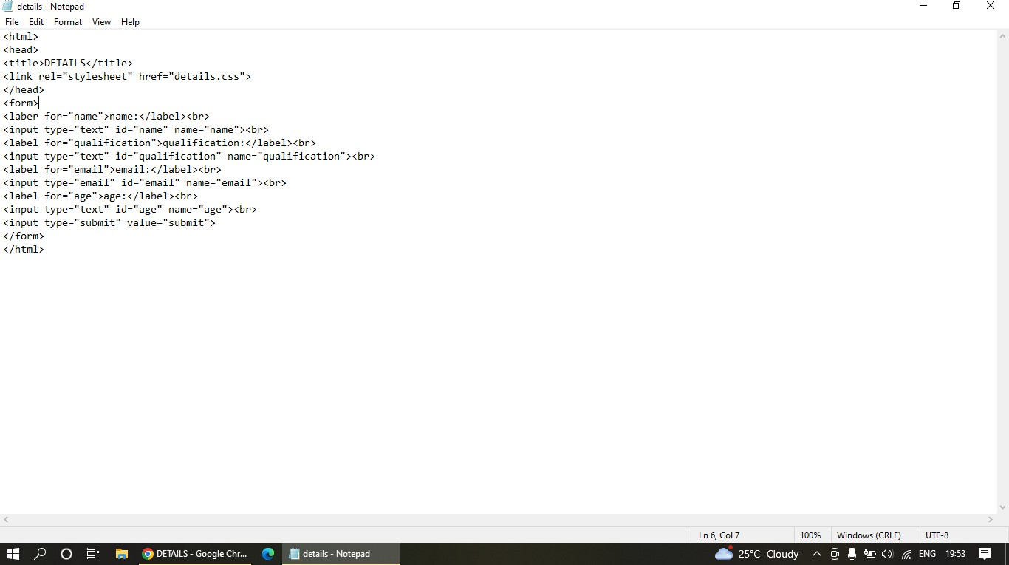

**-name**

**-age**

**-submit button**

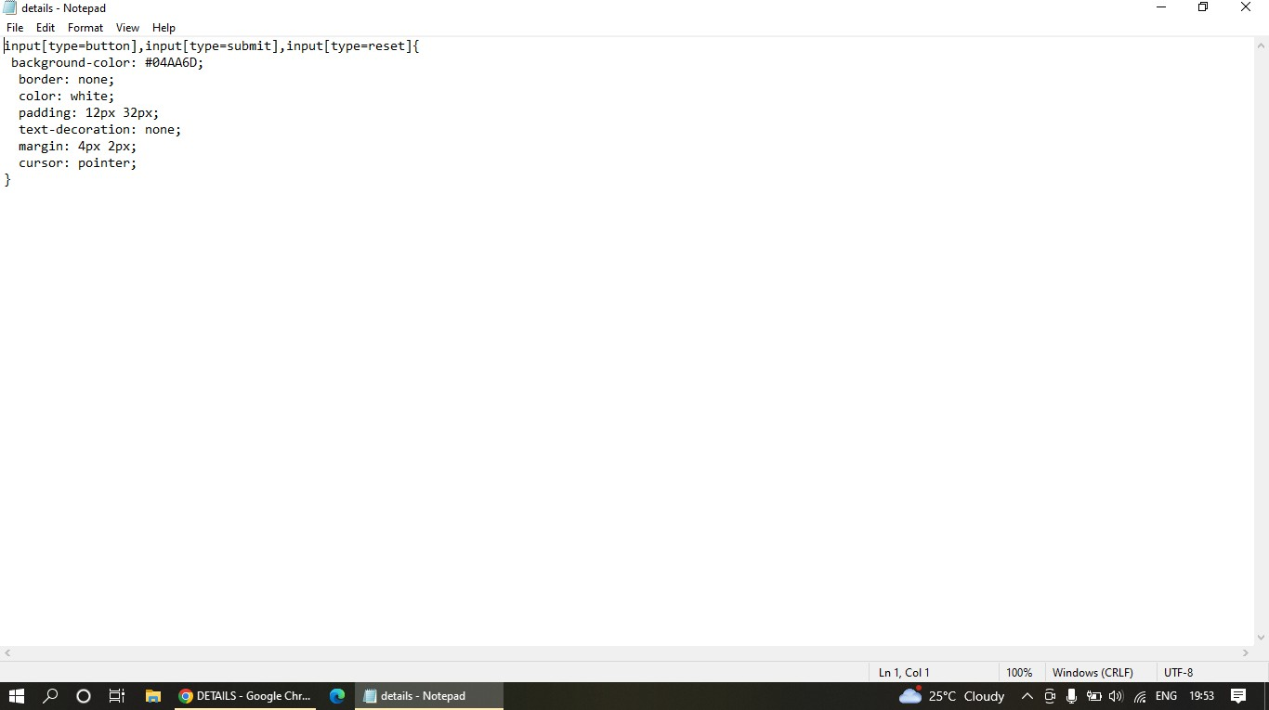

OUTPUT:

